Supplementary Table 1. List of Principal Investigators and Sites participating in the study.
Principal Investigator | Site
Arcusa, Àngels | H. de Terrassa
Gutierrez Torinio, María | H. de Basurto
Romero Martín, Margarita | ICO Badalona
López, Ángela | H. Provincial de Castellón
Guerra Alia, Eva Mª | H. Ramón y Cajal
Martínez, Jerónimo | H. U. Virgen de la Arrixaca
Santaballa Bertrán, Ana | H. U. i Poltècnic La Fe
Mendiola, César | H. U. 12 de Octubre
Sánchez, Ana Beatriz | H. G. U. de Elche
Cueva Balueños, Juan | H. C. U. de Santiago de Compostela
Molano, Fernando | H. Insular de Gran Canaria
Esteban, Carmen | H. Virgen de la Salud (Toledo)
Vicente Baz, David | H. U. Virgen de la Macarena
López de Ceballos, Maria Helena | H. San Pedro de Alcántara
Palacio Vázquez, Isabel | H. Central de Asturias
Martínez Peralta, Susana | H. de Mataró
Bover, Isabel | H. Son Llàtzer
Láinez, Nuria | Complejo Hospitalario de Navarra
García, Alicia | H. Moisés Broggi
Gironés, Regina | H. Lluis Alcanyis de Xàtiva
Herrero, Ana | H. Miguel Servet
Redondo, Andrés | H.U. La Paz
Alarcón, Jesús Damián | H. Son Espases
Beltrán, Miquel | ICO Girona
Maximiano, Constanza | H. U. Puerta de Hierro
Garrigós, Laia | H. del Mar
Casado, Antonio | H. C. San Carlos de Madrid
Rubio, María Jesús | H. Reina Sofía de Córdoba
Fuentes Pradera, José | H. V. Valme, Sevilla
Poveda, Andres | FIVO
González, Antonio | CIO MD Anderson, España

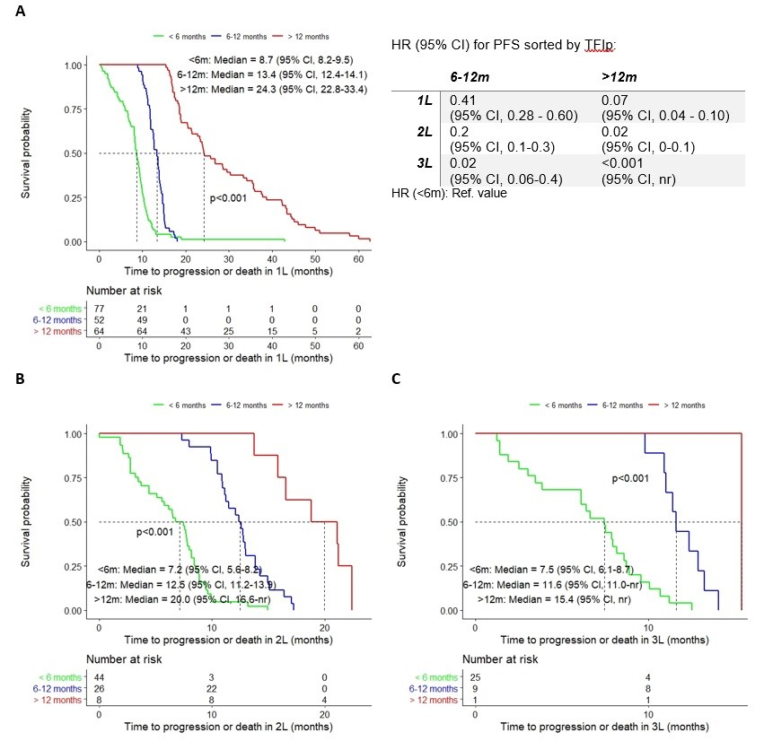
Supplementary Fig. 1. Kaplan-Meier curves for progression-free survival by TFIp after first (A), second (B) and third (C) lines in patients who had received platinum. 1L, first-line treatment; 2L, second-line treatment; 3L, third-line treatment; nr, not reached; TFI, platinum-free interval.

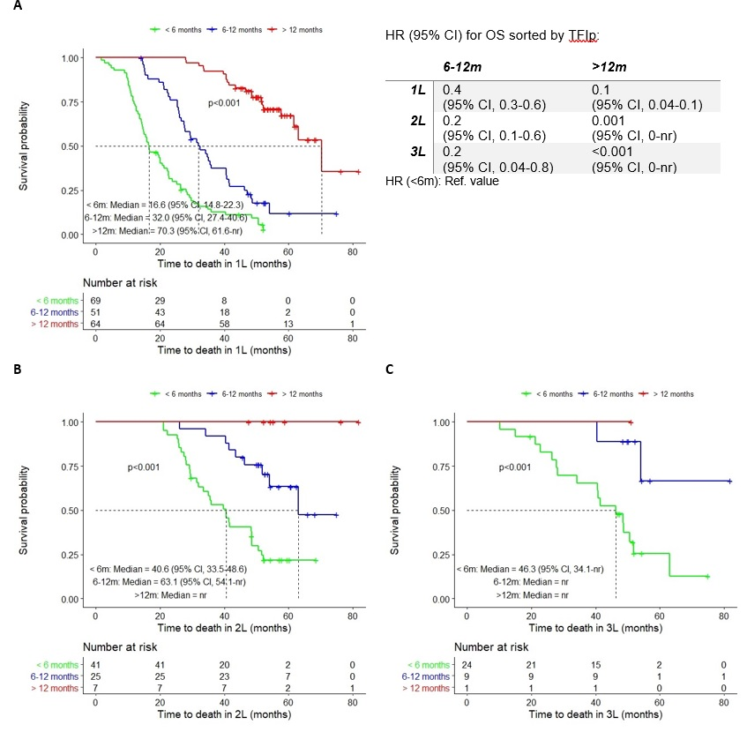
Supplementary Fig. 2. Kaplan-Meier curves for overall survival by TFIp after first (A), second (B) and third (C) lines in patients who had received platinum. nr, not reached; TFIp, platinum-free interval.

